|  |  |
| --- | --- |
| **Homework 2** | **Chapter 7 – Single Dimensional Arrays**  **Chapter 9 – Objects and Classes** |
| **Due June 10 2018 at 11:30pm** | **Objectives**  ■ To solve mathematical problems by using the methods in the Math class  ■ To represent characters using the char type  ■ To encode characters using ASCII and Unicode  ■ To represent strings using the String object |

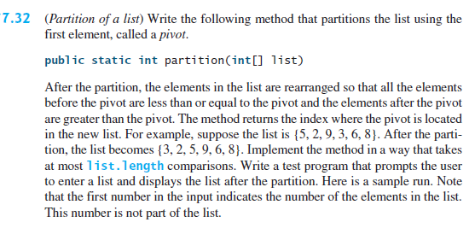



# Reading Exercise: Review the Case Study: Deck of Cards. No submission required

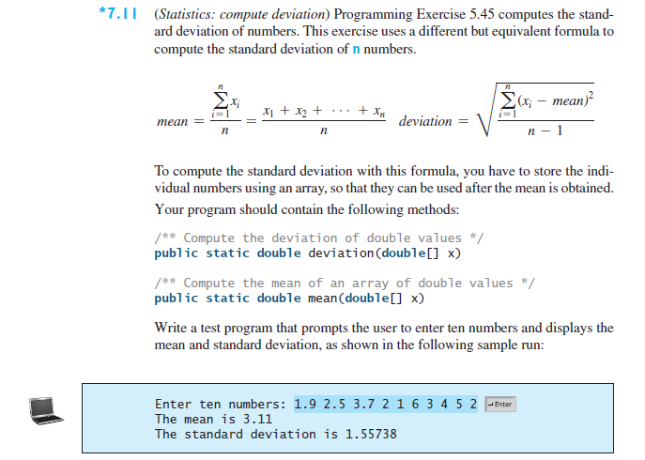

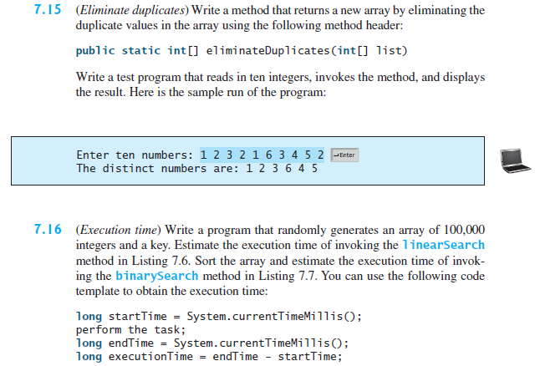

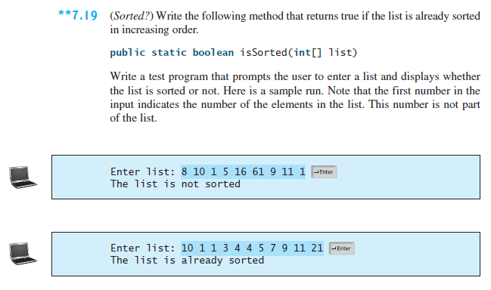

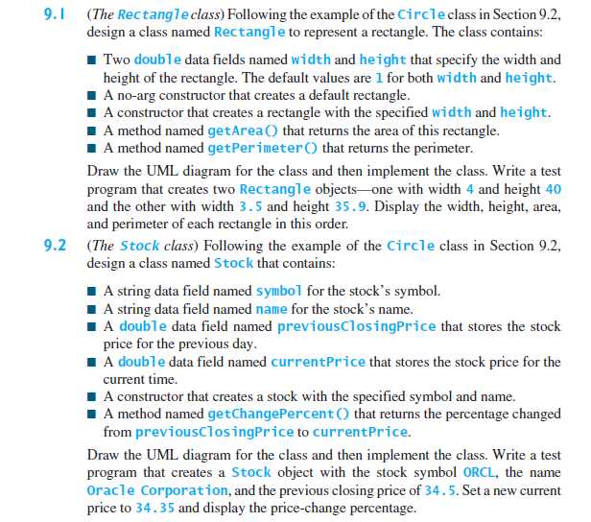

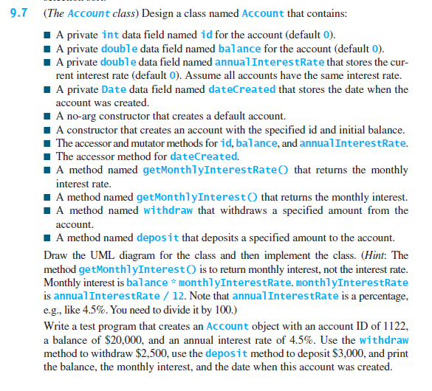 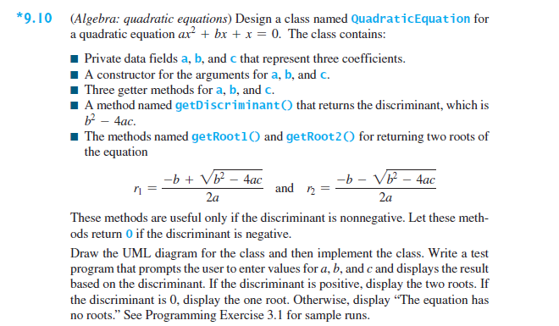

## Task List

You are required to complete the following activities by the deadlines specified and submit the appropriate *deliverables* through eLearning.

|  |  |
| --- | --- |
| Activity | Deadline |
| Create Class Files having its own main method for each of the problems in this assignment. ________________________________________________  Compile, Execute and Test your program | June 10 |
| Zip the Java Files and submit on eLearning |

## Guidelines

You will be graded according to the following guidelines:

* You are required to submit files through eLearning by the specified deadline. You can earn a maximum of 100 points.
* If the files do not compile, you will receive a 0 for the program.
* You are graded primarily on the design of your class and the adequate testing of your class. Poor design or inadequate testing will result in loss of points.
* Your files should be adequately commented. Up to -15 points will be deducted for poor indentation and documentation.